# DOMAIN PROJECT-1

## SYNOPSIS

**ON**

## Topic Name: Pathfinder AI

|  |  |  |  |
| --- | --- | --- | --- |
| **Submitted By** | | | |
| Keertivallabh Sharma | Jyotiraditya Singh | Shrey Sharma | Rishav Singh |
| R2142220539 | R2142220530 | R2142220169 | R2142220149 |

***Under the guidance of***

## Dr. Panduranga Ravi Teja

Professor



# School of Computer Science

**UNIVERSITY OF PETROLEUM AND ENERGY STUDIES**

**Dehradun-248007 Aug-Nov, 2024**

|  |  |
| --- | --- |
| Index | |
| Contents | Page Number |
| Chapter 1: Abstract | 3 |
| Chapter 2: Introduction | 3 |
| Chapter 3: Problem Statement | 6 |
| Chapter 4: Literature | 8 |
| Chapter 5: Objectives | 8 |
| Chapter 6: Methodology | 10 |
| Chapter 7: System Requirement | 10 |
| Chapter 8: PERT Chart | 10 |
| Chapter 9: References | 10 |

# Chapter 1: Abstract

The rapid growth of urban areas and the increasing need for efficient transportation solutions demand innovative approaches for route planning and construction when connecting places like big cities. The government cannot solely rely on the shortest route to connect two cities; they must also consider optimal pathways that integrate major landmarks, key locations, and important destinations. This requires advanced tools and techniques. Our project aims to develop a prototype application that employs a combination of pathfinding algorithms to find the optimal path for constructing a road connecting cities. The proposed solution will allow users to interactively upload city-wide maps, select specific destinations, and mark key points such as hospitals, offices, government buildings, airports, and stations. The application will compute the most efficient route based on factors like the priority of important locations. Through this project, we aim to demonstrate the feasibility and practicality of algorithm-driven decision-making in navigation applications, providing a valuable contribution to enhancing user navigation experiences.

Keywords: Path-finding algorithms, Djikstra’s algorithm, A* algorithm, Route planning,

Road Construction, Mapping Landmarks.

# Chapter 2: Introduction

Efficient route planning plays a major role in enhancing urban mobility and reducing travel time, particularly in rapidly developing nations like India, where constantly developing infrastructure and urbanization present significant challenges. Traditional navigation systems often rely on static data, which inadequately addresses the dynamic nature of urban environments—such as real-time traffic fluctuations, road closures, and the strategic importance of key locations. Consequently, these systems frequently produce suboptimal routes that exacerbate congestion and inefficiencies.

This project aims to overcome these limitations by developing a cutting-edge prototype application that utilizes an advanced version of pathfinding algorithms, meticulously adapted for complex urban settings. The application is designed to enable users to upload comprehensive city-wide maps, select multiple destinations, and prioritize critical locations such as hospitals, government buildings, airports, and educational institutions. By integrating these elements, the system dynamically calculates the most efficient routes, accommodating real-world constraints like traffic density, road conditions, and the significance of specific landmarks.

The proposed solution is not only expected to enhance navigation efficiency but also support urban planning, emergency response, and resource management through a more integrated approach to route optimization. This project encompasses the design of an intuitive user interface, the implementation of robust backend algorithms, and the evaluation of the application's performance using real-world data.

This research seeks to address the gap in traditional routing systems by providing a comprehensive solution that dynamically adapts to real-time conditions and considers the strategic importance of various locations within urban landscapes.

# Chapter 3: Problem Statement

India faces several challenges in developing effective navigation applications due to its vast geography, diverse terrains, and rapidly expanding urban and rural populations. Existing applications often fail to account for critical factors such as high traffic density, varied terrain, and the strategic importance of locations like hospitals, government buildings, and transportation hubs. This results in suboptimal route choices, increased travel times, higher costs, and limited access to essential services for many communities. To address these issues, there is a need for an advanced, data-driven navigation tool that allows users to dynamically select destinations, mark important locations, and optimize routes based on multiple parameters. This project aims to develop a prototype tailored to India’s unique needs, employing a modified version of Dijkstra's algorithm to compute optimal routes, enhance decision-making, and improve navigation experiences across the country.

# Chapter 4: Literature

Efficient design and planning for navigation have long been studied in the context of route optimization [1]. Various algorithms and models, such as Dijkstra’s algorithm, A* search, and genetic algorithms, have been employed to enhance route efficiency, reduce travel time, and minimize costs [2]. Dijkstra's algorithm, introduced in 1959, is a widely used method for finding the shortest path between nodes in a graph and is commonly applied in navigation problems. However, its traditional form does not account for multiple dynamic factors, such as traffic density, route feasibility, or the priority of essential locations, which are crucial in real-world scenarios [3].

Research on route optimization in diverse contexts highlights the importance of considering multiple criteria beyond mere distance [4]. Studies suggest that incorporating factors such as population density, location accessibility, economic benefits, and environmental impact can lead to more effective and user-friendly navigation solutions. Multi-criteria decision-making (MCDM) models and Geographic Information Systems have increasingly been utilized to improve the accuracy and relevance of navigation planning in various geographic and socio-economic contexts.

In recent years, there has been growing interest in integrating GIS with optimization algorithms to enhance navigation applications. It provides a powerful platform for handling large spatial datasets and visualizing complex geographic information, while algorithms like Dijkstra’s can perform efficient computations on these datasets. Previous works have demonstrated that combining with optimization techniques allows for more interactive, data-driven navigation processes that consider multiple constraints and objectives [5].

This project builds on the existing literature by developing a prototype navigation application that integrates modified pathfinding algorithms with GIS-based tools. Unlike traditional approaches, our application allows users to interactively upload maps, select destinations, and mark critical locations, considering diverse criteria such as traffic density, route feasibility, and strategic importance. This approach aligns with the needs of diverse regions, where varied geographic, demographic, and economic conditions require adaptable and context-sensitive navigation tools [6]. By leveraging the strengths of both classic algorithms and modern GIS technology, this project aims to contribute to more efficient, user-friendly, and data-driven navigation solutions.

# Chapter 6: Methodology

The project starts with *Data Collection*, where city-wide maps are obtained from various sources like Open Street Maps (OSM), Google Maps Platform, ArcGIS etc. The next phase is *Data Pre Processing*, in this phase the obtained maps are cleaned and converted into a compatible format for the application. Next, comes *UI development* focusing on creating an interactive user interface for convenience and easy navigation. Following this, the *Algorithm implementation* phase involves applying modified pathfinding algorithms like Dijkstra's, A*, etc., to determine optimal pathways for road construction. The application is then enhanced through integration to visualize the maps and roads effectively. Finally, the project undergoes iteration and deployment, where we will test it and iterate over times, to refine it to satisfaction.

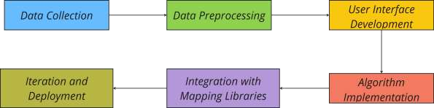

# Chapter 7: System Requirements

## Software Requirements

Operating System : Windows 10/8/7 (32-bit or 64-bit)/ Linux Software : Text Editor, Browser

Compiler : GCC, Python

## Hardware Requirements

Processor : Dual Core 2.7 GHz or better

RAM : 512 MB or higher

Disk Space : 512 MB

# Chapter 8: PERT Chart

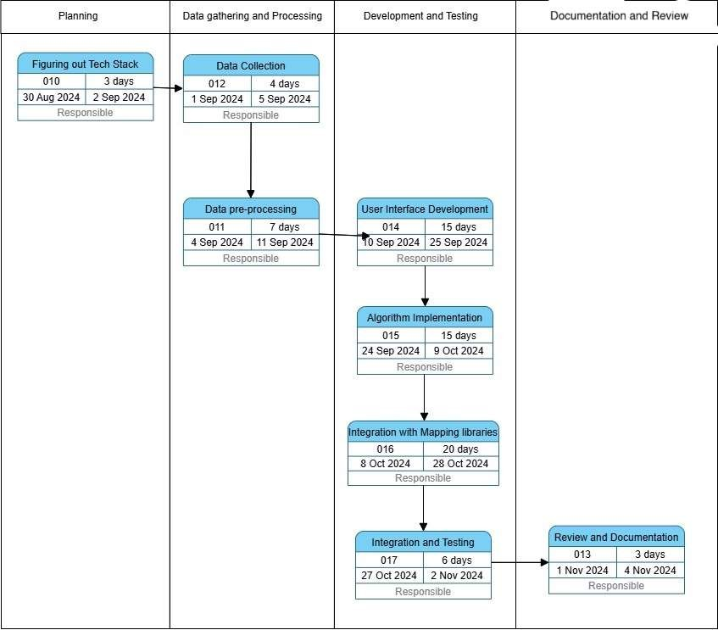

**Chapter 9: References**

* + <https://docs.mapbox.com/help/glossary/mapbox-js/>
  + [Google Maps Platform. (n.d.). Google Maps API Documentation](https://mapsplatform.google.com/india/?utm_source=google&utm_medium=cpc&utm_campaign=google_maps_non_brand_india&gad_source=1&gclid=CjwKCAjwreW2BhBhEiwAavLwfBNDlxkvCX_lpP7-VYcH_TyD8Jumj26N8fO4x3MWLkUL_WY4k_7RDxoChHUQAvD_BwE&gclsrc=aw.ds).
  + [Project Management Institute. (2017). A Guide to the Project Management Body of Knowledge](https://www.pmi.org/pmbok-guide-standards/foundational/pmbok) [(PMBOK Guide) (6th ed.).](https://www.pmi.org/pmbok-guide-standards/foundational/pmbok)
  + <https://www.youtube.com/watch?v=J7eyI1ClDOA>
  + [https://www.iirs.gov.in/iirs/sites/default/files/pdf/2023/Overview_of_Remote_Sensing_and_GIS](https://www.iirs.gov.in/iirs/sites/default/files/pdf/2023/Overview_of_Remote_Sensing_and_GIS_Applications_E-Book.pdf)

[_Applications_E-Book.pdf](https://www.iirs.gov.in/iirs/sites/default/files/pdf/2023/Overview_of_Remote_Sensing_and_GIS_Applications_E-Book.pdf)

* + <https://www.sciencedirect.com/journal/isprs-journal-of-photogrammetry-and-remote-sensing>
  + [1] https://www.researchgate.net/publication/route_optimization_design
  + [2] https://en.wikipedia.org/wiki/Dijkstra%27s_algorithm
  + [3] https://www.journalofnavigation/algorithm_limitations
  + [4] https://www.sciencedirect.com/multi_criteria_navigation
  + [5] https://www.researchgate.net/gis_optimization_techniques
  + [6] https://www.mdpi.com/data_driven_navigation_solutions